Urgent Prayers for the Coronavirus and Ezekiel in the Hospital
February 17, 2020

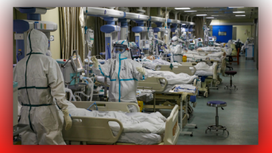
Dear Heartdwellers,

We are writing this message to let you know that our Ezekiel is on his way to a hospital. He's been having some difficulties, and as you know, he did have a wonderful healing of his intestines! And the Lord spoke to him last night and requested that he would go to a hospital.

So, please pray! Clare is on the way with him. Please pray that the Lord’s choice of doctors, nurses, and technicians will be good people; will be ready to receive him and serve him. And have the Lord's heart and purposes in mind. And that the purpose of the Lord that He is sending, will be clearly revealed to them.

Clare would also to ask that we all pray fervently, and and include the Divine Mercy Chaplet, for the sake of those who are dying of this coronavirus who are NOT saved. This has been a very heavy burden on both Ezekiel's and Clare's hearts and minds. And it has been a TERRIBLE burden, the Lord has shown, on the Lord's heart. He's shown this to Ezekiel. Terrible, heavy burden for those who are dying of this disease and have NOT found Him.

Please intercede for these souls, that perhaps, even in their last moments, the Lord will be able to meet them, face them with who they are and who HE is! And snatch them out of the enemy’s hands!

Thank you so much, Dear Heartdwellers! We love you so much! Keep our prayers together for all of us. And please keep the coronavirus sufferers in your mind as this goes through. Not only China, but wherever else it sweeps through.

May the Lord bless you all and keep you. Amen.

